Use-Case Realization Report
AddUserAdministrator

Issue <1.0>
Revision History
Date | Issue | Description | Author
<dd/mmm/yy> | <x.x> | <details> | <name>

Table of Contents
1. Brief Description 4
2. Flow of Events 4
3. Interaction Diagrams 4
3.1 Collaboration Diagram for AddUserAdministrator 4
3.2 Sequence Diagram for AddUserAdministrator 5
4. Participating Objects 7
5. Class Diagrams 8
5.1 Class Diagram for AddUserAdministrator 8
6. Derived Requirements 8

Use-Case Realization Report
AddUserAdministrator

Brief Description

Flow of Events
[enter the flow of events here; you can use subsections to structure the text]

Interaction Diagrams

Collaboration Diagram for AddUserAdministrator
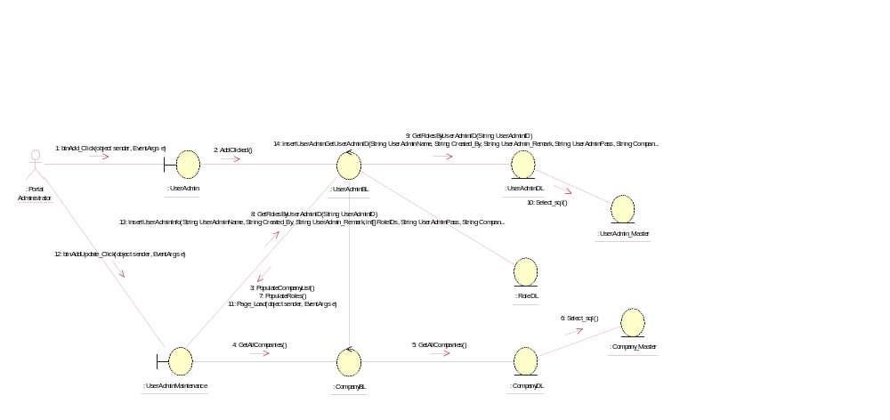

Sequence Diagram for AddUserAdministrator
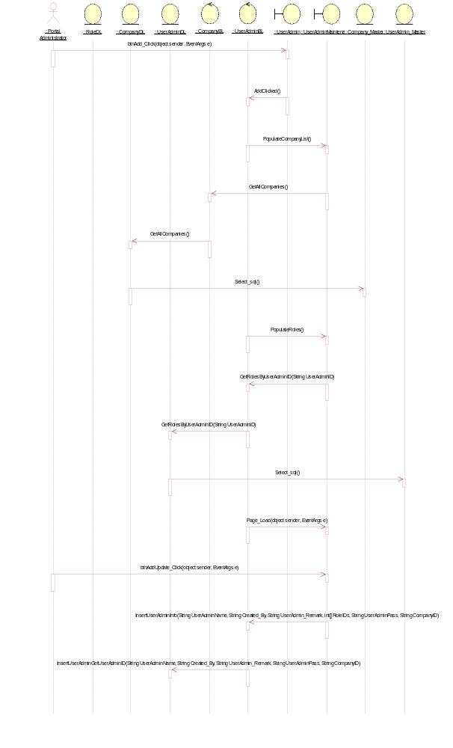

Participating Objects
: Company_Master

: CompanyBL

: CompanyDL

: Portal Administrator

: RoleDL

: UserAdmin

: UserAdmin_Master

: UserAdminBL

: UserAdminDL

: UserAdminMaintenance

Class Diagrams

Class Diagram for AddUserAdministrator
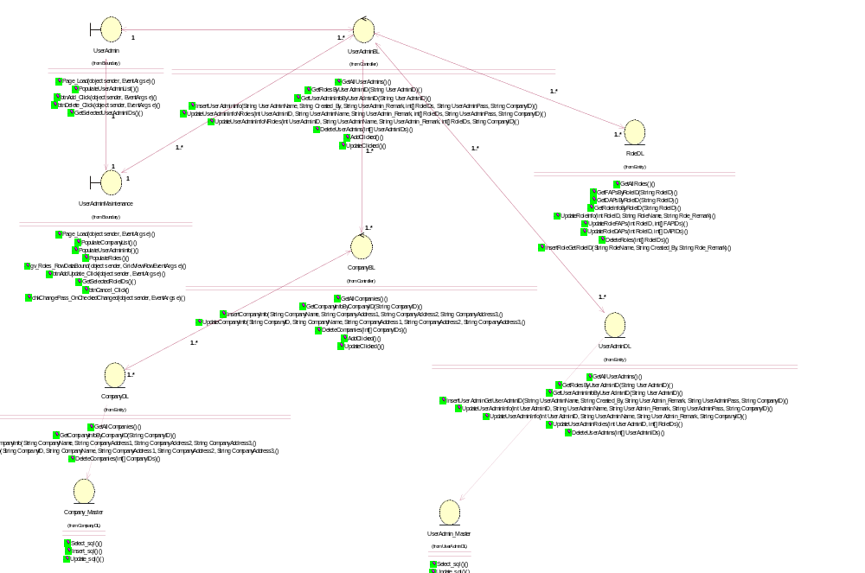

Derived Requirements
[enter the derived requirements here]

